Session 5

- List 3 examples of 'population' and 'sample' in the context of apps you use daily (like Instagram followers, Zomato restaurants, or Flipkart products). For each, clearly define what would be considered the population and what would be a sample.

Example | Population | Sample
Instagram Followers | All followers of an Instagram account | 100 randomly selected followers
Zomato Restaurants | All restaurants listed on Zomato in Ahmedabad | 50 randomly selected restaurants
Flipkart Products | All smartphones available on Flipkart | 30 randomly selected smartphones

- Write a Python script that simulates random sampling: given a list of 1000 fake user IDs (e.g., user1 to user1000), select 50 random users to simulate a survey sample. Print the selected user IDs.<br><br><em><strong>Hint:</strong> Use the random.sample() function from Python's random module.</em>.
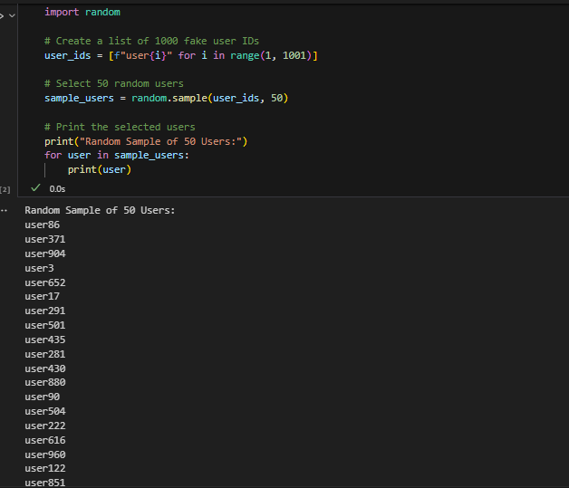

- Imagine you are analyzing food delivery times on Swiggy. Explain in 2-3 sentences why you would use sampling instead of collecting data from every single order ever made.
Sampling saves time and reduces the cost of data collection. Instead of analyzing every order, a randomly selected sample can provide reliable insights about customer behavior and delivery performance
- Given this scenario: A survey about music preferences is only sent to users who recently streamed Bollywood songs on Spotify. Identify and explain the type of bias this introduces in the sample.
Type of Bias: Selection Bias
Explanation: The survey includes only users who recently streamed Bollywood songs on Spotify. It excludes users who listen to other music genres, so the sample does not represent all Spotify users.

- Choose any two types of sampling (for example: random sampling, stratified sampling, systematic sampling, cluster sampling). For each, describe how you would use it to select a sample of users from BookMyShow to study movie booking habits.

1. Random Sampling
Randomly select 200 BookMyShow users from the entire user database. Every user has an equal chance of being selected, making the sample fair and unbiased.

2. Stratified Sampling
Divide users into groups based on age (e.g., below 18, 18–30, above 30). Then randomly select users from each group to ensure every age category is represented in the study

